Project logo (optional) Priority logo

Project no.

Project acronym

Project title

Instrument

Thematic Priority

Deliverable reference number and title

Due date of deliverable:
Actual submission date:

Start date of project: Duration:

Organisation name of lead contractor for this deliverable

Project co-funded by the European Commission within the Sixth Framework Programme (2002-2006)
Dissemination Level
PU | Public
PP | Restricted to other programme participants (including the Commission Services)
RE | Restricted to a group specified by the consortium (including the Commission Services)
CO | Confidential, only for members of the consortium (including the Commission Services)

Report of activity (mars 2004-February 2005) : Design and Nano-Scale Handling of Biological Antetypes and Artificial Mimics.

Deliverable D3-1 : Controlled grafting of catenane and rotaxane units at metal surfaces.

Partners: University of Bologna, MPI-FKF Stuttgart, TU Eindhoven, ULP Strasbourg,

1. Synthesis ( ULP Strasbourg)
Introduction : To visualise the dap chelate and macrocycles m-30 and mt-33 (Figure 1 ; the numbers 30 and 33 indicate the total number of atoms in the rings circumference) represents the first step if one wants to observe large amplitude molecular motions in copper-complexed catenanes. These relatively simple compounds are indeed the building blocks of the catenanes to be elaborated and studied in the future. The compounds have been synthesized and sent to Dr. Nian Lin (research laboratory led by Prof. K. Kern, MPI Stuttgart).
Figure 1
The next step will be to observe, on the surface, two interlocking rings as represented in Figure 2 (catenanes 1 and 2). In a subsequent step, the introduction of copper(I) within these complexing molecules will allow to visualise the motion of the rings, the free molecules rearranging so as to reach the equilibrium position corresponding to the formation of the copper(I) complexes. At this stage, a chemical reaction (oxidation) or an electrical signal should convert the copper(I) complex to a copper(II) species. This process is expected to be followed by reorientation of the rings with respect to one another in the bistable catenane 2. In the preliminary experiments, deposition of the metal-free molecules should be done by UHV vaporisation, whereas another technique will have to be utilised in order to introduce copper ions and the oxidizing reagent in situ.
Figure 2
Synthesis of a switchable rotaxane unit bearing the appropriate functional group for grafting
As a first model, we have started to prepare the threaded molecule 3 of Figure 3a (“pre-rotaxane”) containing :
(1) a bipy unit, which is threaded inside the ring (bipy = 2,2’-bipyridine). This “thread” will constitute the fixed part of the future rotary motor.
(2) a ring, which incorporates both a dpp motif and a terpy fragment (dpp = 2,9-diphenyl-1,10-phenanthroline ; terpy : 2,2’,6’,2”-terpyridine ; dpp is a bidentate chelate whereas terpy is a tridentate chelate).
(3) a sulfur-containing function (thioacetate, thiol, thioether or disulfide), allowing adsorption and grafting of the molecule on a gold surface (Figure 3a).

Figure 3
Stepwise synthesis allowed us to obtain the pseudo-rotaxane 3 in reasonably good yield (31%). Although the thioacetate function has been less frequently used than other functions (thiols or disulfides) to derivatize gold surfaces, we have selected this chemical group for synthetic reasons. It acts as a protecting group during the synthesis and it should be readily cleaved when the compound is reacted with the gold surface.
A detailed ¹H-NMR study of compound 3 shows that the threading reaction of the bipy-containing “filament” is quantitative. All the signals of the ¹H-NMR spectrum could be assigned (2D* ROESY analysis). In order to immobilize a pre-rotaxane and to generate a surface deposited rotaxane attached to the surface in a rigid way, we have designed a new molecular thread, with a novel bidentate chelate consisting of a pyridine nucleus and a disubstituted isoquinoline moiety (Figure 3b) The chemical structure of the thread, with its two anchoring points (S-containing functions), is such that it will prevent the axial stator from rotating. This synthetic work is now pursued in our group.
Grafting of the rotaxane at a surface and study of the electrochemically induced rotation motion.
Electrochemical behaviour of 3 in solution : Cyclic voltammetry measurements show two irreversible signals at 0.73 V and –0.18 V (vs. SCE). These signals correspond to the Cu₄^{II}/Cu₄^{I} and Cu₅^{II}/Cu₅^{I} redox couples, respectively (the subscripts 4 and 5 indicate the coordination number of the copper centre : 4 means that Cu is coordinated to the bipy and dpp units whereas 5 corresponds to a copper complex involving the bipy and terpy fragments). The irreversible nature of these electrochemical signals indicates that the monovalent 5-coordinate species undergoes complete rearrangement, to afford the monovalent tetracoordinated complex. The same holds true for Cu₄^{II}, the thermodynamically unstable divalent 4-coordinate compound, which rearranges to the stable 5-coordinate copper(II) complex. These rearrangements, which can be viewed as a large amplitude motion of the threaded ring (half-turn rotation) about the axis, are fast, considering the high scan rate used (up to 2 Vs⁻¹) to measure the cyclic voltammograms.
The present system is thus set in motion particularly efficiently by an electrochemical signal. It is the fastest copper-complexed rotaxane or catenane to rearrange, among all the compounds made and investigated in our group.
Electrochemical behaviour of 3 on Au surface :
The reaction time required for complete adsorption of the pre-rotaxane on a gold bead is around one week. By electrochemistry, one observes a reversible electron transfer, occurring at a potential E_{p} = 0.61 V (vs. SCE) which corresponds to the Cu₄²⁺/Cu₄⁺ couple. The difference between the oxidation peak potential and the reduction peak potential is ΔEp ~ 80 mV. It is also noteworthy that the cathodic and anodic peak current intensities are slightly different, which tends to indicate that, at least to a limited extent, rearrangement of the intermediate 4-coordinate copper(II) complex Cu₄²⁺ occurs within the lifetime of the measurement (scan rate : 100 mVs⁻¹). The relative inertness of the 4-coordinate copper(II) complex could originate from too close proximity between the ring and the gold surface. In order to circumvent this difficulty, a possible solution would be to “dilute” the dynamic molecular system on the gold surface by proceeding to co-adsorption of thioalcane molecules such as HS-(CH₂)_{n}-CH₃ (n = 17) at the same time as the pseudo-rotaxane 3. In such a way, the ring to be set in motion should be sufficiently remote from the gold surface to be able to move readily, similarly to what was observed in solution.
A similar study has been realized with the analogous complex containing a thiol group instead of a thioacetate function, but its adsorption on the gold electrode surface seems to be problematic, due to the instability of the thiol function and, in particular, its propensity to get oxidized.

Synthesis of a rotaxane with a less encumbered bipyridine coordination site

A rotaxane with a dpp-incorporating axle and the macrocycle mt-33 has been synthesized a few years. The macrocycle was shown to pirouette around the axle upon electrochemical oxidation and reduction of the copper centre. Unfortunately, the response time turned out to be relatively long (about 2 minutes for the 4-coordinate copper(II) complex and ~ 50 ms for the pentacoordinated copper(I) state). More recently, the dpp unit has been replaced by a bipy chelate. In this latter system, the ring rotates rapidly from the terpy complexation site to the dpp-complexing site upon reduction of the copper(II) centre (2 ms). However, when copper(I) was oxidised back to copper(II), the regeneration of the five coordinated copper (II) species was much slower (200 ms).
This led to the following assumptions:
(i) steric hindrance around the axle, due to the presence of the substituents borne by the 1,10-phenanthroline nucleus in ortho to the nitrogen atoms, like in the dpp fragment of the first system, is very unfavourable and
(ii) the presence of voluminous stoppers close to the copper centre is likely to slow down any reorganisation process occurring within the metal coordination sphere .
Therefore, we started to plan the synthesis of an axle containing a 2,2'-bipyridine moiety as bidentate coordination unit and for which the stoppers are remote from the central complex so as to interfere as little as possible with the geometrical changes. As macrocyclic component, mt-33 was chosen, by analogy with previous experiments. Indeed, m-33 is small enough to remain threaded on the axle with the tri(tertbutyl)phenylmethyl stoppers. As far as the axle is concerned, we selected triethyleneglycol chains as spacers between the bipy coordination site and the two stoppers. After several chemical reaction steps we obtained 16 mg of the pure ligand 4, corresponding to an overall yield of 8.3 %.(Figure 4).

4

Figure 4

The electrochemical behaviour of Cu.4 has been examined in CH₃CN solution by cyclic voltammetry at a platinum electrode. Starting from the ligand 4 and the corresponding stoichiometric amount of Cu(CH₃CN)₄⁺, it is possible to generate in situ and quantitatively the copper(I) rotaxane Cu.4. Preliminary results indicate that the motion of the ligands around the copper(II) centre, from the tetra-coordinated form to the penta-coordinated state, is very fast at the time scale of the cyclic voltammetry. At a scan rate of 2 Vs⁻¹, both at room temperature and at – 40 °C, no signal corresponding to the reduction of the 4-coordinate copper(II) species could be observed. These experiments seem to confirm that destabilisation of the copper(I) complex could be achieved both by removing the substituents in alpha position to the nitrogen atoms of the 2,2'-bipyridine ligand and by increasing the distance between the stopper units and the coordination site. In conclusion, these two parameters appear to be determining and will allow us to optimize the design of future fast-moving molecular machines.

2. Vacuum deposition at metal surfaces (MPI-Stuttgart)
Vacuum sublimation of catenane molecules
The compounds (cf. figure 1) synthesized by the Strasbourg group have been tested in a special mass spectrometer in order to determine their sublimation temperature under ultra-high vacuum conditions. Sample dap can be evaporated intact at about 150 deg. Sample m-30 and mt-33 have much higher sublimation temperatures, which are beyond the temperature range of the mass spectrometer apparatus. Currently we are constructing a new ultra-high vacuum system that has the capability to determine the sublimation points of higher mass compounds. The preliminary results show that the mt-33 is sublimated at 585 K. We also have obtained the first STM data of mt-33 at a Cu(100) surface. Figure 5 reveals that the molecules accumulated at the steps of the surface can be resolved by STM - the ring-like feature is evident. On open terraces the molecules are very mobile at room temperature, giving rise to the ‘spiky’ noise in STM data.
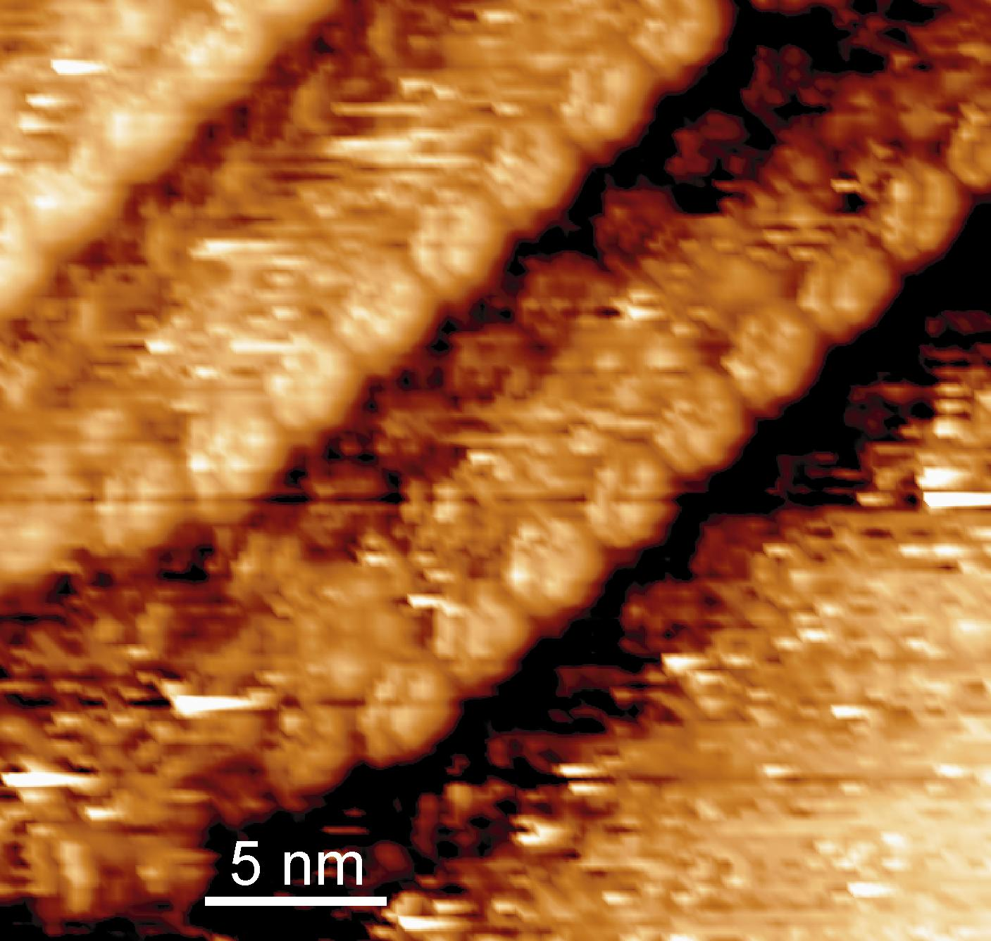
Figure 5

Surface patterning and functionalization
It is important to attach the catenane and rotaxane molecules at surfaces in a controllable way for future application of molecular motors. To achieve this goal, we have developed various routes to pattern and functionalize metal surfaces that may be used as templates to anchor the catenane and rotaxane molecules.
The first approach is to use 1,3,5-tricarboxylic benzoic acid (trimesic acid, TMA) molecules and Fe atoms as building blocks to assemble mesoscale networks comprising a regular arrangement of homochiral nanocavities at a Cu(100) surface. As shown in figure 6, these nanocavities present identically shaped ∼1 nm diameter hosts, equally spaced by 3.43 nm from each other and functionalized by eight carboxylate groups in a well-defined arrangement. The distinct size, shape and chemical functionality make the nanocavity arrays a promising candidate to be employed as host system for the selective adsorption of molecular guests. In addition to its chemical functionality the homochiral nature of the nanocavities is of great interest for enantioselective recognition and asymmetric catalysis. The precise positioning of the molecules and the metal centers at the surface opens up new possibilities for the bottom-up fabrication of complex functional nanomaterials.
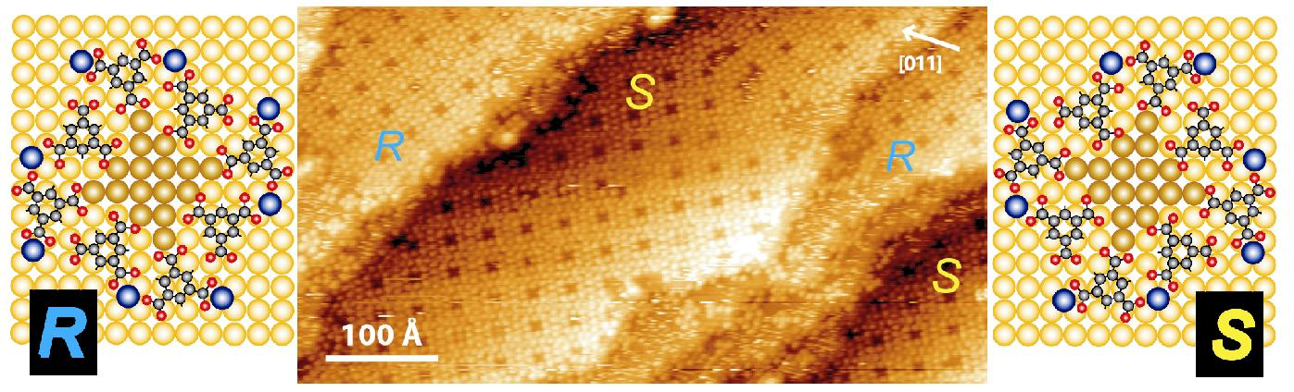
Figure 6
We have made preliminary testing on the hosting ability of the nanocavities. Various organic molecules, e.g., cystine, C₆₀, phenylalanine dipeptide, 4-[trans-2-(pyrid-4-yl-vinyl)]benzoic acid (PVBA) and 1,4’-biphenyldicarboxylic acid (BPDA) (cf. figure 7), were successfully included in the nanocavities by vapor deposition in an ultra-high vacuum environment.
In-situ scanning tunneling microscopy revealed the characteristics of the inclusion at the single-molecule level, which provides unprecedented information on host-guest binding configurations, binding sites, and host structural deformations upon uptaking the guests. The binding strength was quantified by the thermal desorption experiments, which also demonstrate distinctive releasing behavior for different guests, signifying the selectivity and reversibility of the host-guest inclusions. In particular we found that functional group substitution plays a remarkable role. Figure 7 shows on an example that the dipeptide molecules are included in the nanocavities in an up-right standing configuration.

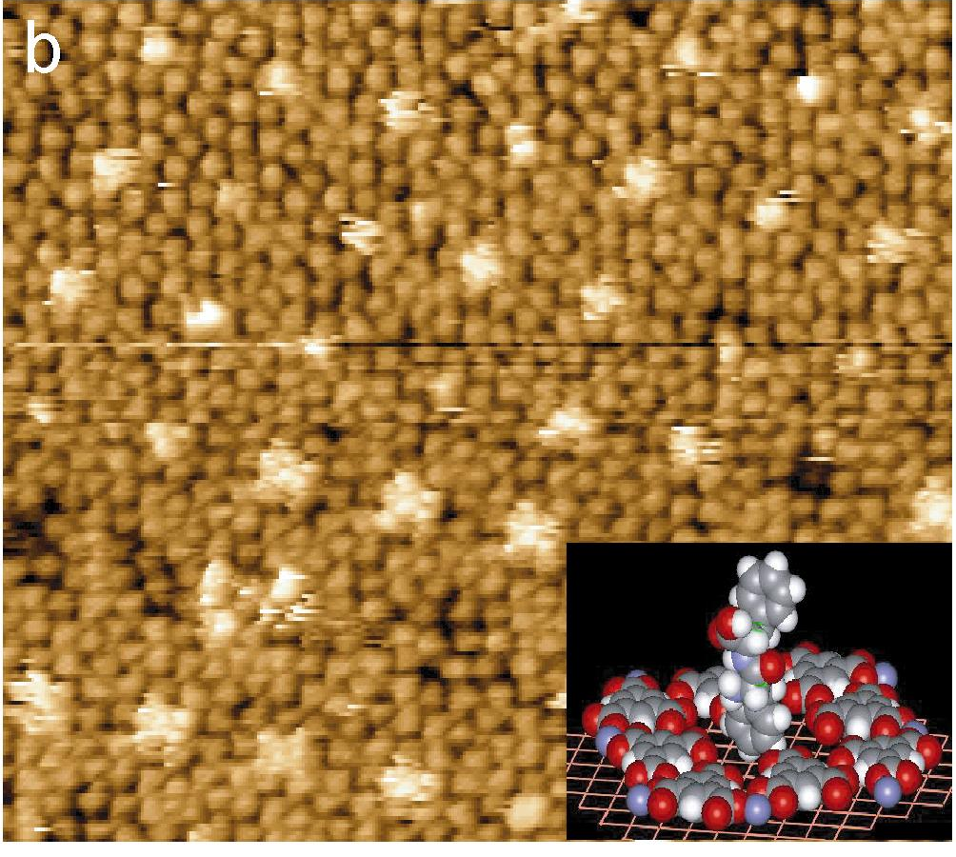
Figure 7

As a next step selected catenane and rotaxane molecules that contain special designed endgroups will be brought to the pre-patterned surface in vacuum by thermal sublimation. In particular compounds a and b shown in figure 3 are suitable candidates.
The second method is to fabricate 2-dimensional networks containing large voids and confine the catenane or rotaxane molecules in these voids. We chose a molecule, tricarboxylic acid, which has been synthesized by the Karlsruhe group, as the starting unit. The molecules have been successfully sublimated in vacuum onto a Ag(111) surface. They self-assemble as honeycomb network architectures as shown in figure 8. Figure 8b reveals that the intermolecular interactions are hydrogen bonds between the carboxylic endgroups.

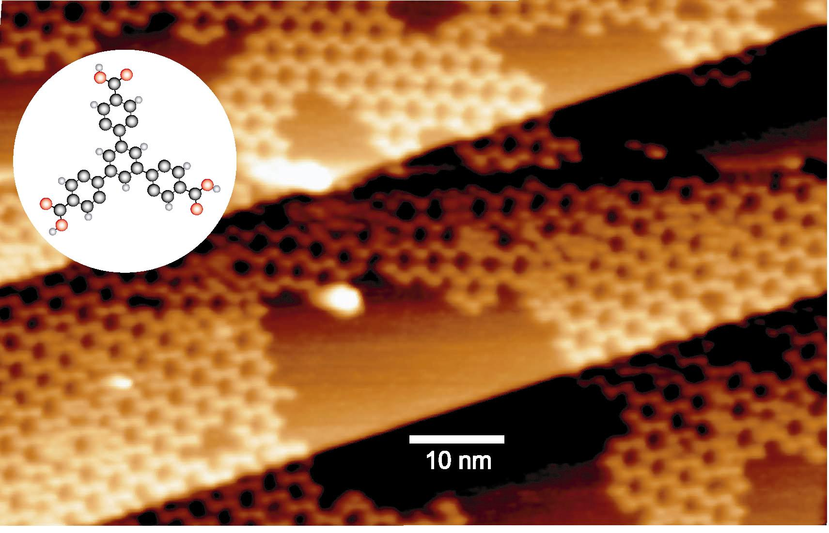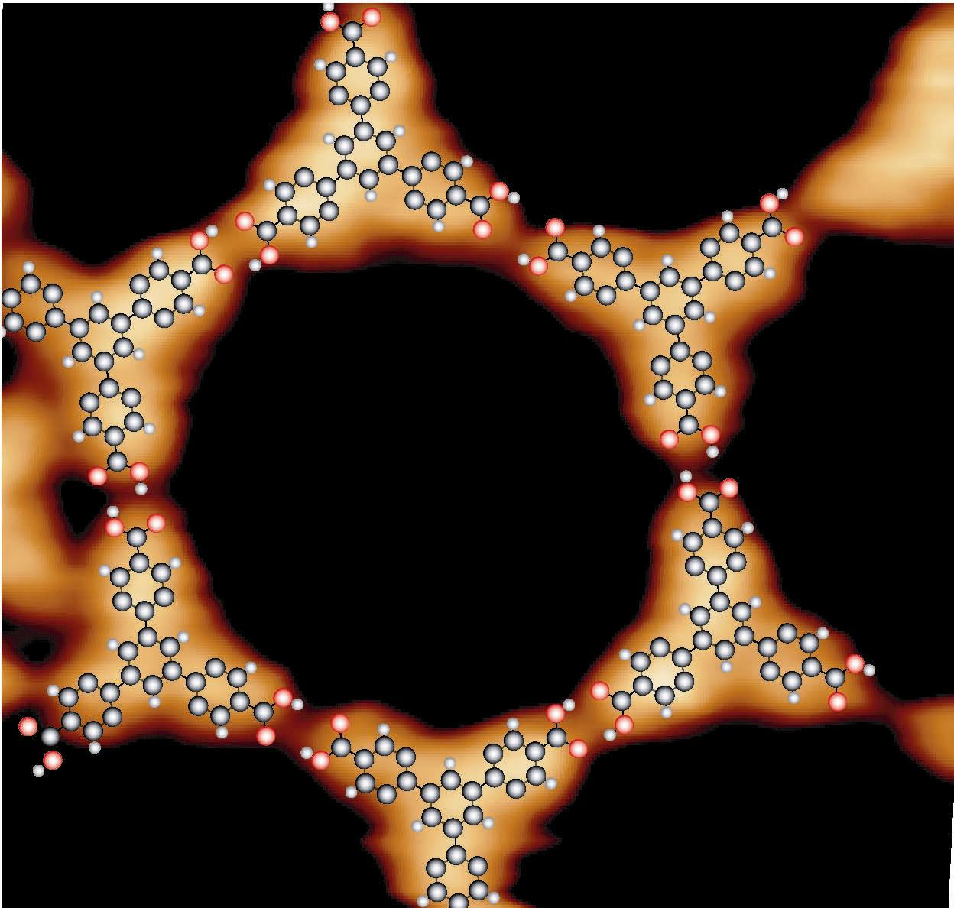
a b
Figure 8

The diameter of the open voids is as large as 4 nm, which is suitable to accommodate various catenane or rotaxane molecules. Because of the perfect long-range ordering of the voids, one may use this surface as a template to organize the catenane or rotaxane molecules as well-defined arrays at a surface.

