Project logo (optional) Priority logo

Project no.

Project acronym

Project title

Instrument

Thematic Priority

Deliverable reference number and title

Due date of deliverable:
Actual submission date:

Start date of project: Duration:

Organisation name of lead contractor for this deliverable

Project co-funded by the European Commission within the Sixth Framework Programme (2002-2006)
Dissemination Level
PU | Public
PP | Restricted to other programme participants (including the Commission Services)
RE | Restricted to a group specified by the consortium (including the Commission Services)
CO | Confidential, only for members of the consortium (including the Commission Services)

WP4. Integrate appropriate Light-Fueled Molecular Components (LFMC’s)
into nanomotors as alternative fueling concept

Deliverable 4-1

During the past few years the miniaturization race has encouraged scientists to investigate the possibility of designing and constructing machines on the nanometer scale, i.e., at the molecular level (see, e.g., V. Balzani, A. Credi, M. Venturi, Molecular Devices and Machines – A Journey into the Nano World, Wiley-VCH, Weinheim, Germany, 2003). Such a daring goal finds its scientific origin in the existence of natural molecular machines (D. S. Goodsell, Bionanotechnology: Lessons from Nature, Wiley, New York, 2004). Nature provides living systems with complex molecules called motor proteins which work inside a cell akin to the macroscopic machines we build for our everyday needs. Equipped with these biological engines, we can walk and talk, and even think.
Natural molecular machines and motors are extremely complex systems. Their structures and detailed working mechanisms have been elucidated only in a few cases (Molecular Motors, M. Schliwa, Ed., Wiley-VCH, Weinheim, Germany, 2002) and any attempt to construct machines of such a complexity, using the bottom-up molecular approach, would be a hopeless task.
What can be done, at present, is to construct simple prototypes of artificial molecular machines, consisting of a few components capable of moving in a controllable way, and to investigate the challenging problems posed by interfacing them with the macroscopic world (For a recent example, see X. L. Zheng et al., J. Am. Chem. Soc. 2004, 126, 4540), particularly as far as energy supply is concerned.
Natural motors are autonomous: they keep operating, in a constant environment, as long as the energy source is available. By contrast, the fuel-powered artificial motors described so far are not autonomous since, after the mechanical movement induced by a chemical input, they need another, opposite chemical input to reset, which also implies generation of waste products.
Addition of a fuel, however is not the only means by which energy can be supplied to a chemical system. In fact, Nature shows that, in green plants, the energy needed to sustain the machinery of life is ultimately provided by sunlight. Energy inputs in the form of photons can indeed cause mechanical movements by reversible chemical reactions without formation of waste products.

Contribution of CIAM Group
In the frame of the present STREP project we have shown that in the rotaxane 1⁶⁺ (Scheme 1) the shuttling process of ring R between the two “stations” A₁ and A₂ located along the dumbbell-shaped component takes place in solution as a result of light energy inputs. In such a two-state rotaxane the more stable co-conformation is the one in which the ring component R encircles a bipyridinium unit A₁. Shuttling of the ring for approximately 1.3 nm between the two stations A₁ and A₂, a bipicolinium unit, can be obtained by three distinct working mechanisms, namely (i) a sacrificial mechanism, based on the participation of external reducing and oxidizing species, (ii) an intermolecular mechanism, involving the assistance of an external electron relay, and (iii) a purely intramolecular mechanism. When shuttling occurs via mechanisms (ii) and (iii), the two-state rotaxane behaves as an autonomous linear motor powered by visible light. Its operation takes place in four strokes: destabilization of the stable co-conformation, displacement of the ring, electronic reset, and nuclear reset.

Scheme 1

At room temperature the deactivation time of the high-energy state obtained by light excitation is about 10 μs, and the time period required for the shuttling of the ring from the initial to the final state is about 100 μs. The system works in ambient conditions, and converts ~10% of the photon energy into mechanical movement.
The efficiency of this motor when it works in an autonomous way with the assistance of an external relay – and even more so when it works purely with an intramolecular mechanism – is low particularly in comparison with the performance of natural motors. It should be noted, however, that the operation of the system is based on the challenge that a complex nuclear motion can compete with an electron transfer process. The design of the two-state rotaxane can in principle be improved upon, thanks to the experience gathered in this work. First, a photosensitizer exhibiting a much longer lifetime, e.g., a [Ru(bpy)₃]²⁺-type complex bearing pyrene substituents on the ligands, could be used. Under such conditions, a longer spacer – which is expected to slow down electronic reset in the intramolecular mechanism, thereby increasing the efficiency of the ring translocation from A₁– to A₂ – could be inserted between the photosensitizer and the electron acceptor units, without compromising the efficiency of the photoinduced electron transfer process. The efficiency of the motor could also be improved by changing the exergonicity of the electron transfer processes (Scheme 2, steps 2 and 5) or by linking a secondary electron donor to the ligands on the P component. Finally, a more rigid rotaxane structure could prevent the presence of folded conformations, lowering the shuttling barrier thereby facilitating the movement of the ring.

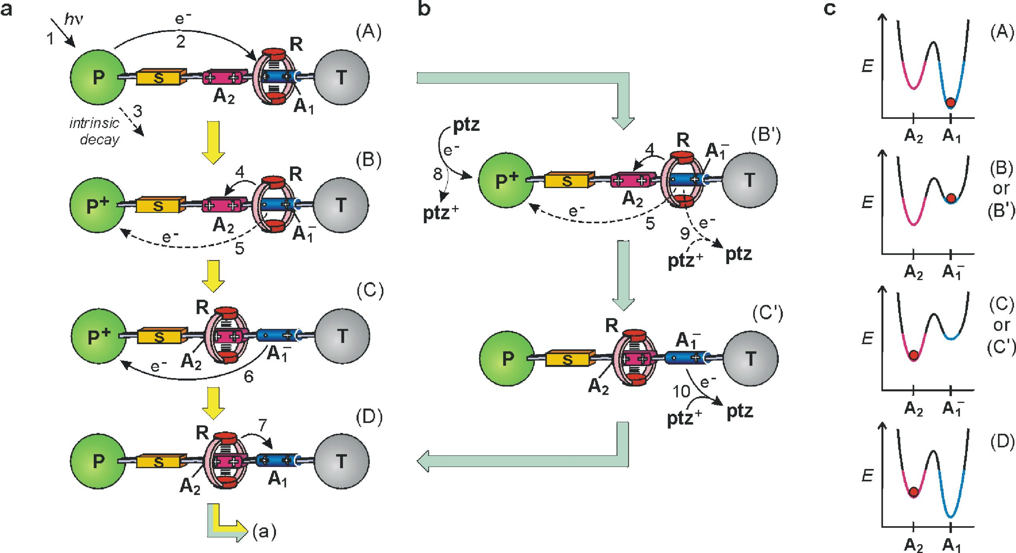

Scheme 2

Contribution of FZK-INT Group
In its simplest definition, a nanomotor is a nanoscale structure capable of converting energy to work. Approaching the naometer regime requires new paradigms and concepts for fueling and controlling that pivotal conversion. The obvious challenge is to develop nanomachines whose motion can be externally controlled and that can be refueled continuously. In an explorative study, we would like, based on prevoiously obtained results of our network, to investigate new concepts of powering the nanoworld.
Thus, a molecular device is envisaged in order to modulate a mechanical molecular translational motion triggered by light through a well described cis-trans isomerisation reaction of a 4,4´- dicarboxy-azobenzene. This isomerization reaction is well described in solution and bulk material (Y. Okahata, H.-J. Lim, S. Hachiya, J. Chem Soc., perkin Trans. 2 1984, 989-994), however has not been observed under near-surface conditions yet.

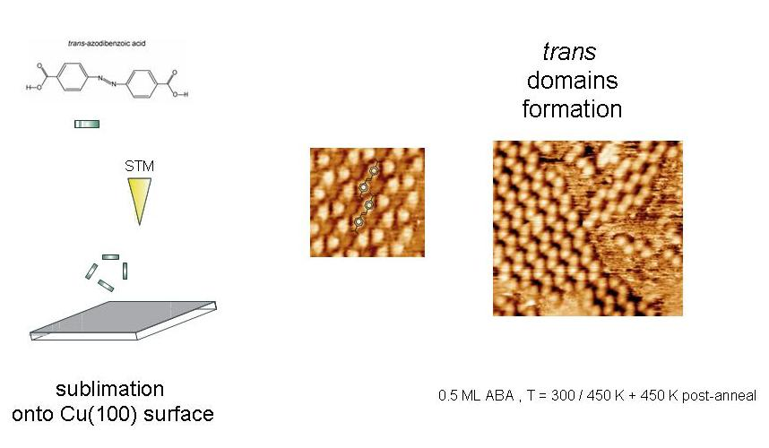
Figure 1: Sublimation of 4,4´- dicarboxy-azobenzene onto the surface and STM-images of the observed monolayer formation exhibiting the molecule as its trans-isomer at the Cu(100) surface.

In order to prove our concept of near-surface isomerization, compound 4,4´- dicarboxy-azobenzene was synthesized following an modified protocol from literature (A. Kumar, G. Bhattacharjee, J. Ind. Chem. Soc. 1991, 523-525). In the following step, the compound was sublimed within a UHV-chamber onto a Cu(100) surface, where the monolayer formation was followed by STM techniques (Figure 1). Exclusively trans-domain formation could be observed. The conclusive irradiation experiments are in preparation in collaboration with MPI-FKF and scheduled for the next milestone.

Preparation of 4,4´- dicarboxy-azobenzene

Sodium hydroxide solution (35.9 g, 0.9 mol) in H₂O (125 ml) was added drop-wise to a suspension of 4-Nitro-benzoic acid (10 g, 59.8 mmol) and H₂O (125 ml). The mixed suspension was heated at 50ºC and then D-glucose solution (75 g, 418 mol) in H₂O (125 ml) was added drop-wise. Air was introduced into the resultant solution at room temperature for 18 h. The orange solid obtained, after filtration, was dissolved in H₂O and acidified with HCl 5 M. The orange solid obtained was recristallized in hot DMF.
Yield 3.80 g (14.3 mmol, 24 %). ¹H NMR (DMSO, δ) 13.22 (s, 2H, broad peak, COOH), 8.17 (d, 4H, J=8.4Hz), 8.04 (d, 4H, J=8.4Hz); ¹³C NMR (DMSO, δ) 167.45, 155.11, 134.35, 131.51, 123.62ppm. M. P.= 338-340 ºC for C₁₄H₁₀N₂O₄: 270.24g/mol.

Contribution of ETH Group
Our part in this project is to provide a better understanding of the atomic mechanisms which rule the behavior of a molecular nanomotor. We focus on a two-state rotaxane which has been well characterized by the group of Prof. Balzani. The system is composed of a dumbbell-shaped part that is encircled by a crown-ether ring which displays a shuttling movement between two charged stations. At equilibrium, both have a +2 charge but electrochemical reactions or light inputs can reduce one of them inducing the movement of the ring. Our aim is to compute the energy barriers related to this process and to understand at the atomic level how the movement occurs.

Tools
The tools that we use to tackle this problem are all atom molecular dynamics (MD) simulations and the metadynamics. The latter is a very powerful scheme that allows for a fast and accurate exploration of the free energy surface. Its working principle is very simple and can be divided in two steps. The first consists in identifying the relevant coordinates (collective variables) of the process we are interested in. This is indeed necessary to reduce the dimensionality of the problem and thus to speed up the search in the free energy hyper-surface. The second step consists of performing MD simulations with the addition of a time dependent potential which favors the escape from the free energy minima. This potential can be easily obtained as a sum of gaussians centered on the previously visited configurations. It is thus evident that such a time dependent potential discourages the system from remaining in the same configuration and that we can obtain the profile of the energy basin by simply inverting this potential.

Technical details
The MD simulation are performed with the NAMD code and the AMBER force field. The atomic charges for the rotaxane are obtained by fitting the ab-initio electrostatic potential with the RESP method. We use a cubic simulation box of about 8nm in side and the rotaxane is surrounded by acetonitrile and PF₆⁻ counter-ions to neutralize the system.

First Result
A first set of plain MD runs were necessary to obtain an equilibrated configuration and to identify the relevant collective variables. In this simulations we always observed that at equilibrium at least one PF₆⁻ molecule remains stuck to the rotaxane, whichever the starting configuration. This contrasts with the common believe that the counter ions are well separated from the rotaxane. However, since we could not completely exclude that this is not due to the small size of our simulation cell, in the metadynamics runs we force the counter ions to remain far apart from the rotaxane, postponing a more careful analysis of this point to a later time.

Second Result
Starting from different initial configurations we could clearly identify the presence of two deep basins of attraction, corresponding to the ring encircling the two stations. We also noticed that the ring is highly flexible and that it tends to maximize the number of hydrogen bonds with the two charged stations. Therefore, the collective variables that allow to distinguish in which of the two basins of attraction one can find the system are: the position of the ring along the dumbbell and the number of hydrogen bonds formed between the ring and the charged stations. We performed many metadynamics runs using different numbers and combinations of collective variables for the reduced configuration and concluded that at least three are necessary to correctly reproduce the physics of the system. The best choice appears to be the position of the ring along the dumbbell, the number of hydrogen bonds formed with the first station and with the second station, separately. In this case we determined the barriers for this process and the relative depth of the two minima. The barrier for the ring moving from the +1 station to the +2 station is of 8 Kcal/mole and of about 13 for the reverse process but the calculation has not yet fully converged. Both value are slightly smaller than the values suggested by the group of Prof. Balzani, 12 and 14 Kcal/mole, respectively. To this point is worth underlying that the estimated accuracy of our values is of about 1.5 Kcal/mole and that the role of the counter-ions is still under investigation. The same calculations for the case in which both the stations are in the +2 oxidation state are now in progress.

Third Result
We observed many smooth shuttling processes and we could identify the atomic mechanism which can be sketched in three steps. First the ring breaks the hydrogen bonds with the hosting station assuming an almost orthogonal position with respect to the dumbbell, second it shuttles towards the other station and finally it rotates, re-forming the hydrogen bonds with the new hosting station.

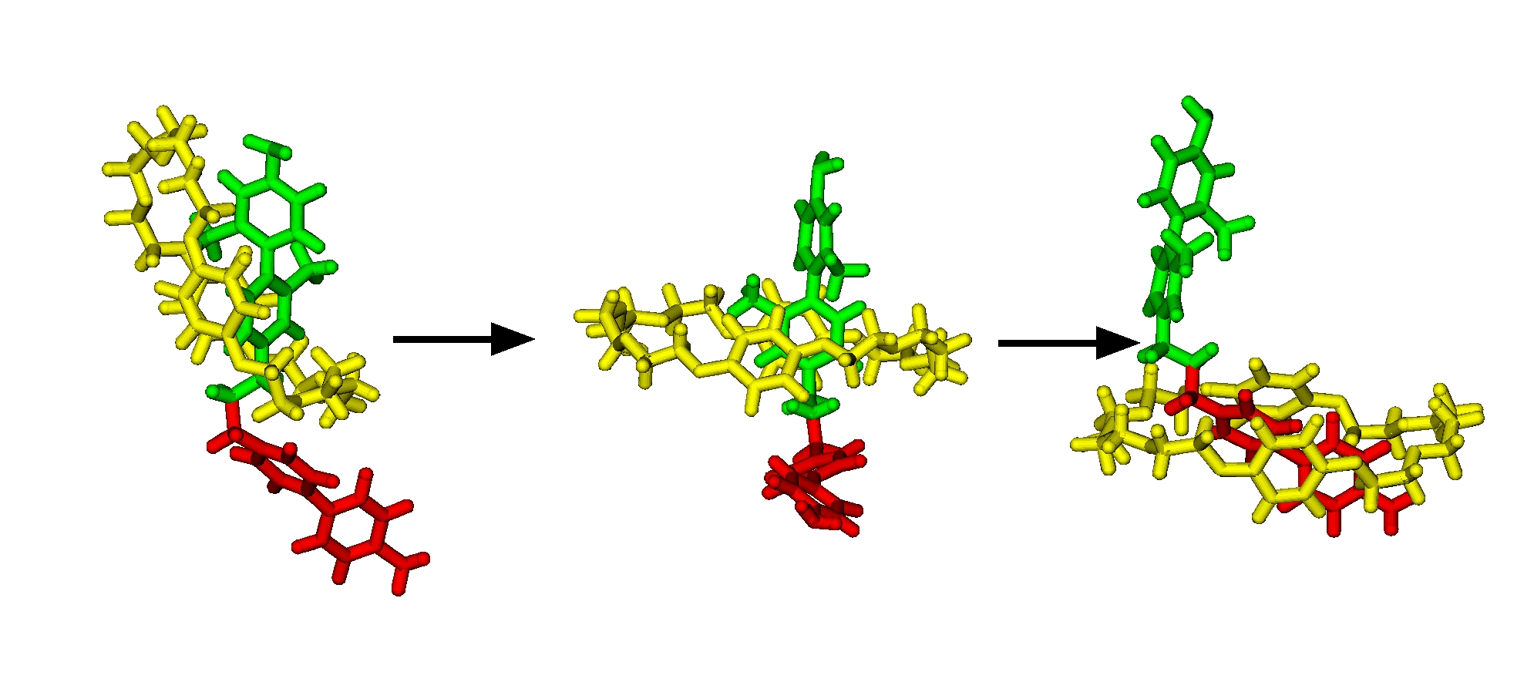

Figure: Movement of the crown ether (yellow) from one green station to the red one. For clarity the solvent, the counter-ions and the rest of the rotaxane are not displayed

