Modification of the vesicles and proteins involved in protein-importing molecular motors such that specific linkages to micron-sized beads can be achieved.

Introduction

Embedded in cellular membranes one finds molecular motors that fulfil the intriguing task of grabbing a folded protein, unfolding it, and translocating it across the membrane. Without this activity cellular systems and organelles could not exist. Cellular organelles rely on import because they cannot synthesize the proteins they use inside. Aberrant protein translocation and folding have been linked to hereditary diseases like primary hyperoxaluria, which causes kidney stones at an early age and some forms of inherited high cholesterol, as well as illnesses like cystic fibrosis.

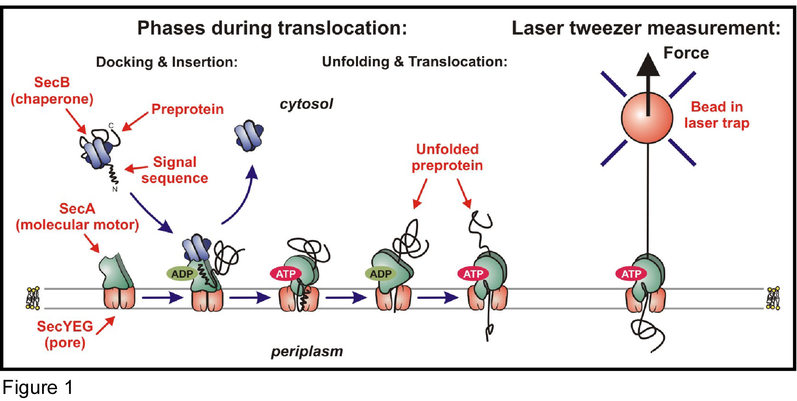
figure 1: Schematic of protein translocation across a cellular membrane, and the measurements of an individual translocation event using optical tweezers.

Of the bacterial Sec translocase, a detailed knowledge of its components and their interactions has been obtained from biochemical and genetic studies (Fig 1 and 2). A picture emerges of an intriguing and highly dynamic process in which cycles of ATP binding and hydrolysis by the SecA motor drive the step-wise translocation of the preprotein through the SecYEG pore. However, the more detailed picture is puzzling and controversial. The main reason for this is that biochemical assays cannot address molecular movements and forces. Further progress in the understanding of protein translocation crucially depends on knowing how the molecules actually move. Direct measurements of the position of a single protein as it progresses through the pore is therefore required, for which laser-tweezers are ideally suited.
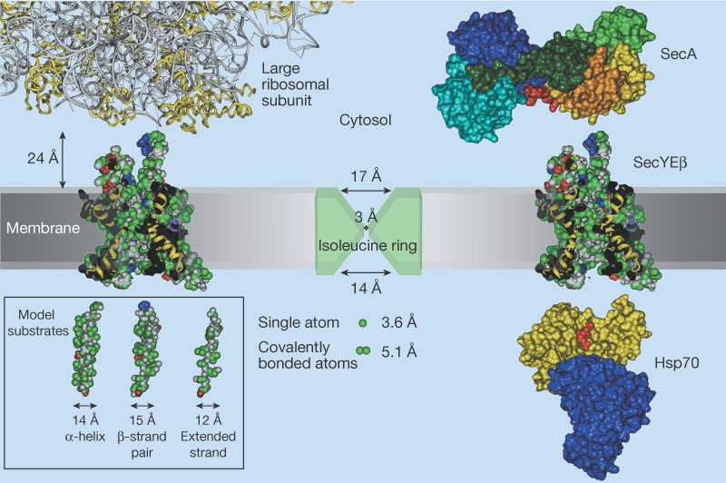
Figure 2: Atomic structure models of protein translocation machines (from: van den Berg et al, Nature, 427, 2004)

Objective D5-1

In order to measure translocation of single proteins, we must show that we can attach them to microspheres that serve as handles to manipulate them, as shown in figure 3. The same holds for the membrane vesicles, in which the translocons reside, at the other end of the construct. Here we report on our results for several routes that we have tested for these attachments. The report shows that all desired attachments have been achieved, but that an aspecific interaction between the preproteins and the vesicles needs to be reduced, for which we outline several possible solutions.
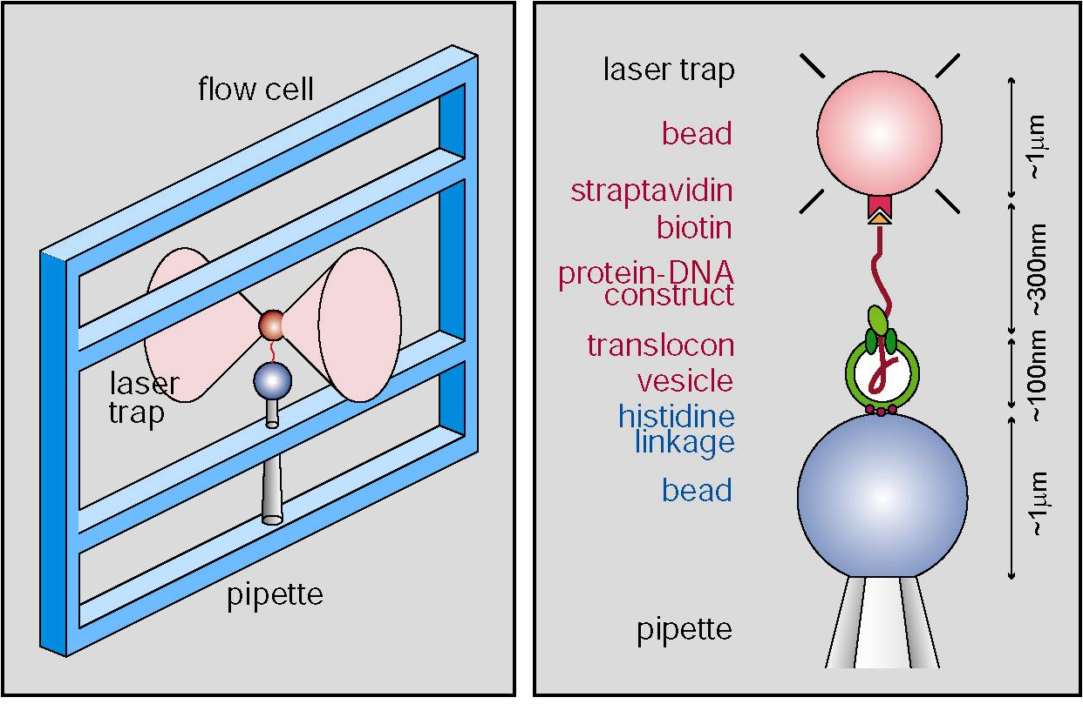
Figure 3: Schematic of the laser tweezers and desired molecular construct. The red-labeled bead is trapped by a focused laser bead in a fluid flow-cell. Movements generated by the tethered molecular construct yield a measurable deflection of the laser beam. The molecular construct show that the translocated protein must be attached to the red bead, while the translocon, residing in a membrane vesicle, must be attached to the blue bead that is held by a micropipette.

Proteins

The translocated protein that have been tested contained the following necessary ingredients: 1) attachment site on C-terminal end, for linkage to bead. In order to have a flexible construction, we have chosen for a biotin group for this function, which would allow both for a direct linkage to the bead, as well as an indirect linkage via a DNA tether (see Figure 4). signal sequence on N-terminal end, for recognition by translocon. 3) increased length for significant measurement time. We tested a protein with an 8-fold repeated domain, as designed at the level of the DNA that encodes the protein (see figure 4). The repeated domain also will likely yield repeated features in the eventual translocation measurements. 4) Additional spacer or tether between bead and protein to prevent interference of pipette bead with laser beam. For this purpose we used a DNA tether of roughly 2 microns length. The best results were obtained with a DNA linker with DIG groups on one end, and a biotin group on the other. We then used a anti-DIG antibody coated bead as the trapped bead, while a streptavidin molecule served as a bridge between the DNA tether and the protein.

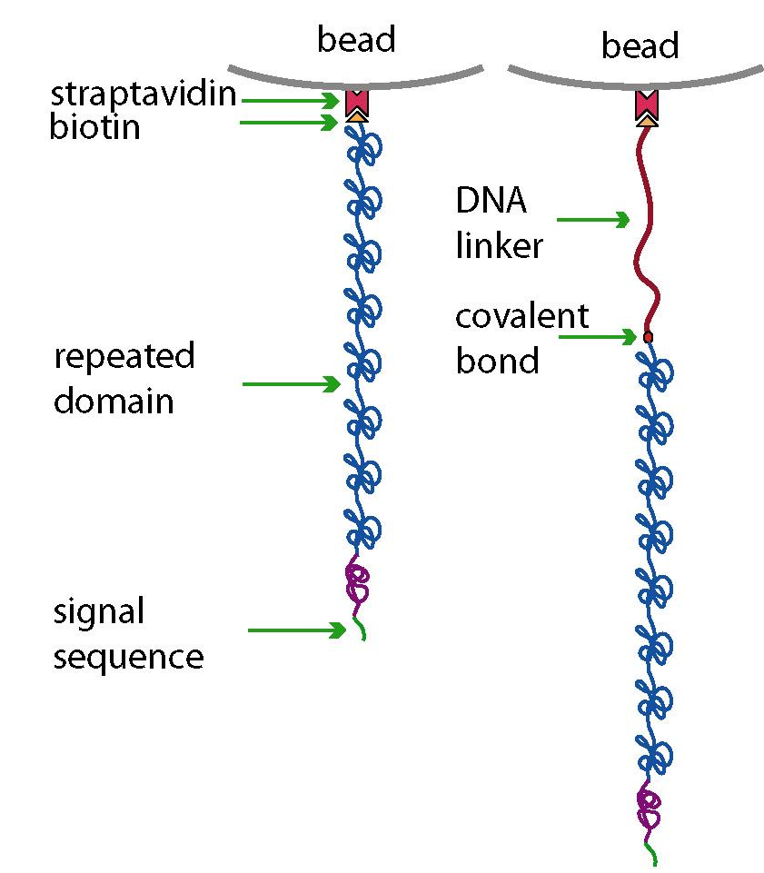
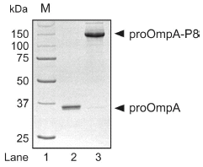

Figure 4: Schematic of the protein constructs, as well as a gel showing the original model protein proOmpA and the proOmpA-P8 or P8 construct that has an 8-fold repeated domain.

Vesicles

The vesicles can be seen as ‘balloons’ made of actual cell membrane material. The cells from which they are made are genetically modified to overexpress the translocation channel, such that all vesicles, which have been sized to a diameter of about 100nm, contain 1 or more translocation channels. In order to attach these vesicles to the blue-labeled bead, we mainly tested 2 different routes. In the first, we tested vesicles with HIS-tagged labeled translocation channels. These HIS tags, which can be introduced at the level of the DNA in the cell that encodes the channels, can be bound to anti-HIS-antibodies. These antibodies were purchased and covalently bound to the beads using a standard chemical protocol. However, we found that this desired linkage was not able to form for unknown reasons. One possibility is that other, such as electrostatic, interactions between the vesicles and the beads were of a repelling nature. Given these results, we then aimed to exploit these possible electrostatic interactions: vesicles are predominantly negatively charged, and we thus tested positively charged amine coated beads. This combination yielded good results, as illustrated by a fluorescence assay testing for vesicles on beads (Fig. 5).

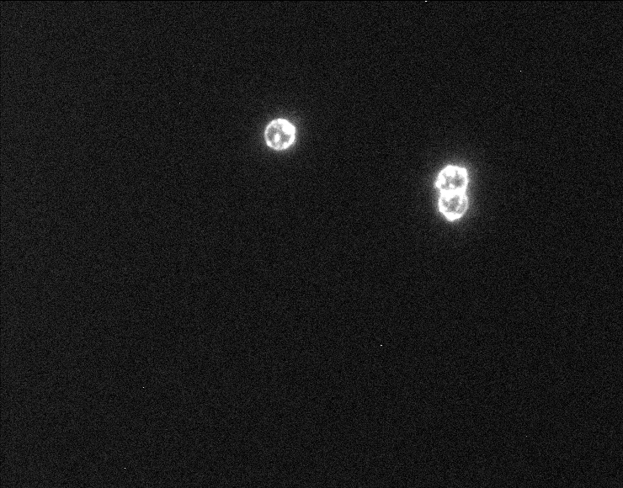
Figure 5: Assay showing that the vesicles attach to amine beads. These vesicles were biotinylated, and made visible with fluorescently labeled streptavidin. Coating of the beads with the blocking agent BSA yielded much less fluorescence intensity.

Measuring interactions using optical tweezers.

In order to obtain the complete construct, all components must be brought together. Whether indeed the molecular construct can bridge the two beads, can be tested in the laser tweezers apparatus, of which a schematic is given in figure 6. Note that many of the attachments do not require other reagents, which means that we have a large freedom in putting all the elements together. In these tests, the beads that are dressed with molecules are brought together with the tweezers so that the bridge can form. As the beads are separated again, a measured force on the trapped bead will indicate a linkage to it. We will now summarize the several routes of construction that we have tested and their results.

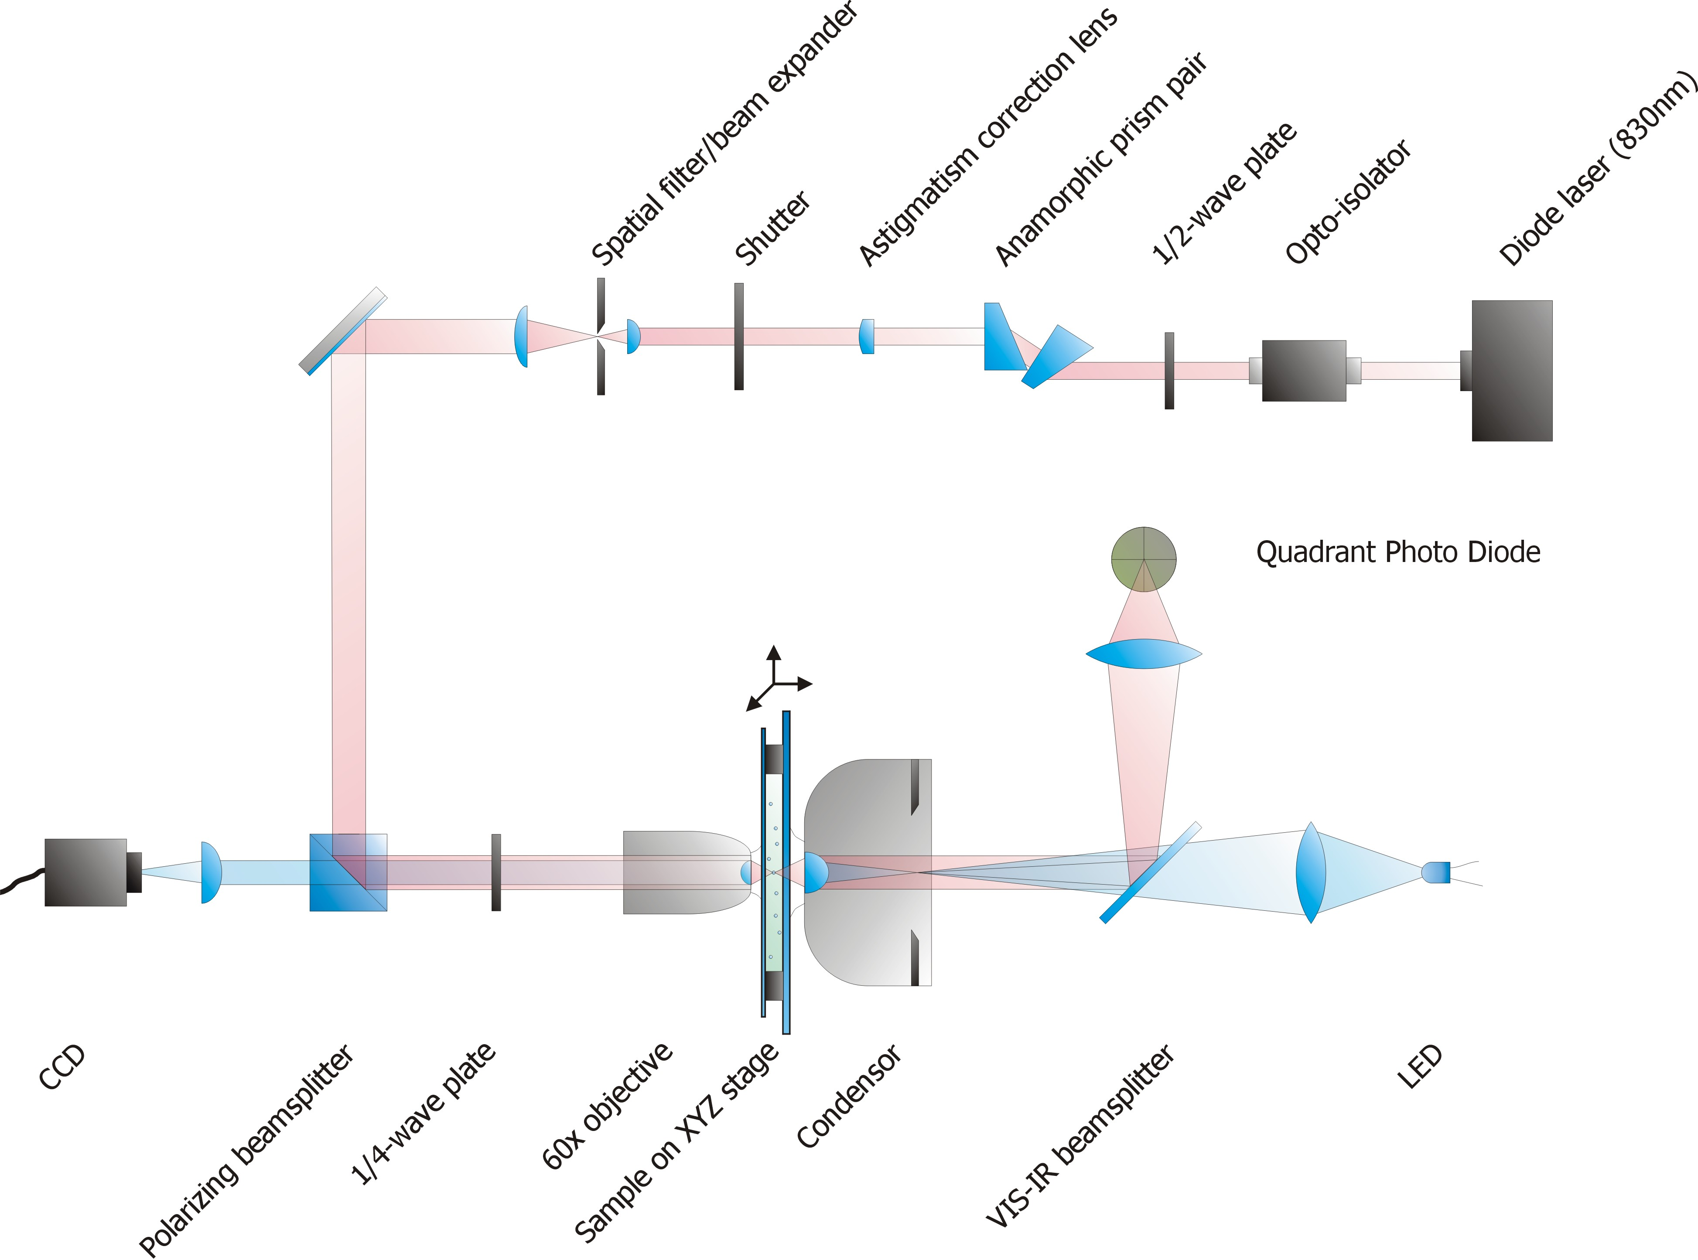
Figure 6: schematic of the laser tweezers set-up. The laser output (red) is first shaped to a gaussian beam, and then focused by a 60x water immersion objective. The focus inside the liquid-filled flow-cell traps the microspheres that have a different refractive index. A condenser collects the light and projects it on a quadrant photo detector, which detects deflections of the laser beam.

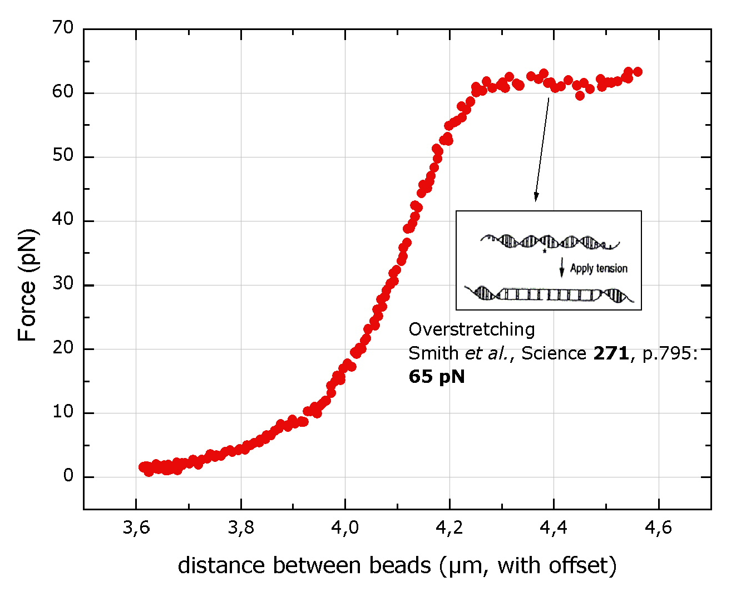
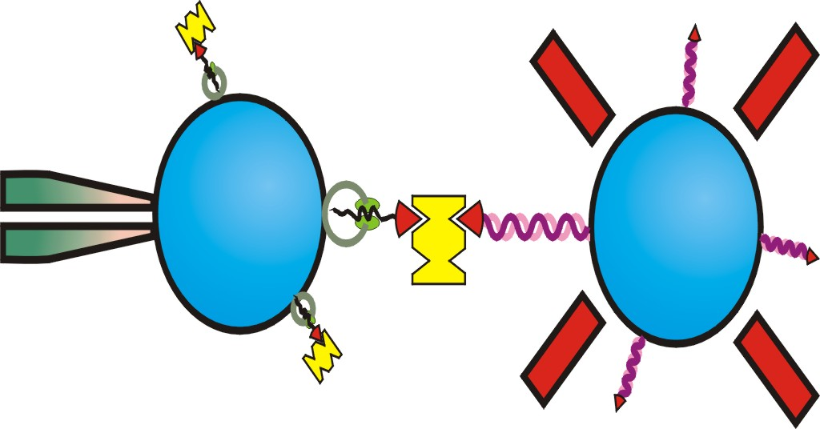
Figure 7: Laser-tweezers measurement evidencing that the molecular construct bridges the two beads. This brigde is able to support the force required for overstretching the DNA. Inset: desired construct, showing the preprotein inserted into the vesicle, and attached to the DNA linker via streptavidin (yellow). The DNA is attached to the bead via a DIG-antiDIG interaction.

First we tested the two DNA linkages alone, using DIG-antibody coated beads and streptavidin coated beads. We found that with multiple DIG groups incorporated in one DNA-end, using standard PCR and ligation, very strong and specific attachments could be made that reached beyond the overstretching transition of about 65pN. Next, we tested the Attachment strength of the vesicles to the amine beads by using biotinylated vesicles, to which we could connect with the DNA tether. Again, strong tethers were able to form beyond the overstretching transition, showing that the vesicles attached strongly as well.
In order to better control the protein insertion process, we developed a protocol that does not rely on uncertain insertion in the tweezers apparatus. In this protocol, proteins were partially translocated in bulk, and prematurely stopped by the addition of ATP-Gamma-S, which does not hydrolyze. In this fashion we could produce vesicles that should have the biotin group of the partially translocated protein exposed to the outside.
Using the sucrose cushion method, we were able to purify –in bulk- excess streptavidin away from the rest of the components (see inset Fig. 7). The effect of this purification step was measured in the laser tweezers, by a marked decrease in aspecific tethers which would form even in the absence of vesicles on the amine beads. Later, we obtained even better purification results by first attaching the vesicles to the beads, followed by spinning down the beads. With the aim to reduce the unwanted aspecific interaction of the streptavidin to the amine beads, we tested the protocol of first adding the streptavidin to the DNA coated anti-DIG beads, followed by washing. We found that in this manner, unwanted aspecific attachments were not able to form.
Furthermore, from several construction routes we could conclude that the P8 protein is able to make aspecific interactions to the vesicles. For instance, without adding the ATP that drives the insertion, bridges between the beads were still able to form. A candidate for this interaction is the hydrophobic beta-barrel domain in the protein, which is present as one copy just after the signal sequence. Because molecular bridges with this interaction will mask the translocation activity, we have identified several ways to deal with this issue. Among those is the tuning of the excess P8, to optimise the specific interactions. Also, we aim to make a new protein construct that lacks the beta barrel domain.

Conclusions

In conclusion, specific and strong linkages of the protein and vesicles to beads has been achieved, fulfilling the objectives for this period. After realizing further improvements to the aspecific P8-vesicle interactions, we can begin looking for movements generated by the protein translocation machinery.

