Project logo (optional) Priority logo

Project no.

Project acronym

Project title

Instrument

Thematic Priority

Deliverable reference number and title

Due date of deliverable:
Actual submission date:

Start date of project: Duration:

Organisation name of lead contractor for this deliverable

Project co-funded by the European Commission within the Sixth Framework Programme (2002-2006)
Dissemination Level
PU | Public
PP | Restricted to other programme participants (including the Commission Services)
RE | Restricted to a group specified by the consortium (including the Commission Services)
CO | Confidential, only for members of the consortium (including the Commission Services)

Microtubules assemblies on nanostructures

Introduction

The biological cell utilizes motor proteins for the active transport of material. For example, the kinesin-microtubule complex is essential in intracellular transport, mitosis and many other biological processes: the kinesin motor proteins can bind to a cargo and walk along microtubules, which are long and stiff tubular proteins. One single kinesin moves processively along the microtubules by discrete steps of 8 nanometers, which corresponds to the microtubule periodicity, and it develops a force up to ~7 picoNewtons.
In order to characterize the power stroke of the kinesin, we developed in the past years a novel optical technique: the Interference Total Internal Reflection Microscopy (ITIRM). This method is based on the detection of the light scattered by a single particle moving through a light pattern. This pattern is generated by interference of two laser beams. Measurement of temporal variation of the scattered light allows us to estimate the position of the particle. This technique allows nanometer resolution and in principle sub-millisecond time response.
The scientific focus of these studies is the achievement of detailed kinematical description of the kinesin power stroke. This is essential to understand the mechanism of energy conversion used by the molecular motors: the experimental results will be compared with the microscopic models, which have been solved by analytical and numerical methods.
The main project of WP6 was to replace the interference pattern (periodicity ~200 nm) by a solid-state nanofabricated structure, integrated in the cover glass. This method would have combined very short pattern periodicity (down to tens of nanometers) and an improved stability.
The technical aim of this project was to fabricate a substrate that integrates the nanostructures and a bio-compatible layer. In such a way it would be possible to attach the microtubules perpendicularly to the pattern.
Furthermore, we also wanted to explore the use of biomolecular motors as transporters in nanotechnology, profiting their natural ability in organizing networks of lipids and pulling vesicles and nano-tubes out of liposomes.

Nanofabrication and Traveling Wave Tracking

The Delft group had extensive experience in nanofabrication: for a start they supplied linear 300 nanometers trenches, with the intention to use the micro-fabricated structures as an added tool for bead tracking assay. These structures have been characterized both by Scanning Electron Microscopy (Figure 1) and by Optical Microscopy. The optical observations showed a non-trivial light scattering near the structures edges, with a strong dependency on the wave-vector direction of the incident light (Figure 4c). This feature makes very difficult to precisely determine the light intensity profile close to the structures and, therefore, the intensity-position relationship becomes obscure.

Figure 1 : SEM image crossection of 300 nm wide trench. Image was taken in an intermediate stage of the processing. On top of the quartz there is first ~35 nm of Cr, and then ~200 nm of PMMA (e-beam resist). The SEM image perspective should be compared to the schematic drawing. The rounded trench bottom and the under etch under the Cr layer can be observed.

Meanwhile a new interference approach has been developed in the Curie group: the Traveling Wave Tracking technique (TWT). The experimental setup is described in Figure 2. In this technique, a particle is moving through the traveling interference pattern; the measurements of the intensity and phase of the scattered light allow to precisely track the particle in a two dimensional plane and to measure simultaneously the position x (parallel to the surface) and the distance z between the particle and the surface. This method seems to be really promising because it allows great spatial and temporal resolution and an improved stability: the particle can be localized with sub-nanometer precision at the microsecond range.
The resolution and the performances of the Traveling Wave Tracking have been characterized using a piezoelectric stage, which moves a bead stuck to the coverglass. Figure 3shows two 10-nanometers steps in a row, acquired with full bandwidth (time resolution of 1.6 µs): the 10 nanometers displacement are easily observed and the internal structure of the step can be characterized with nanometer precision. The oscillatory motion after the step is due to the inertial behavior of the piezoelectric stage: without any feedback loop, it oscillates with exponentially damped amplitude after step-like impulses. The intrinsic noise of the experimental setup can be measured by analyzing the parts of the curve where the oscillations are completely damped (see Figure 3b). The plot shows that the intrinsic noise is 3 Angstroms RMS; this noise, which is white and totally uncorrelated, is due the residual shot noise.

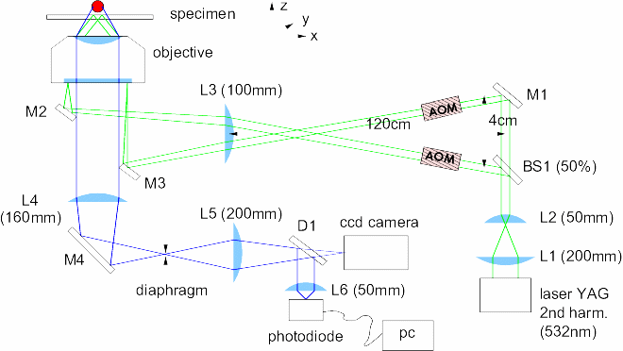 | Figure 2 : Schematic of the experimental setup. Traveling Wave Tracking configuration through the TIRF objective. The two laser beams are focused on the diameter of the back focus plane, in order to light the sample with two parallel beams with opposite wave vector k_{x}. The light scattered by the probe is recorded using an avalanche photo-diode

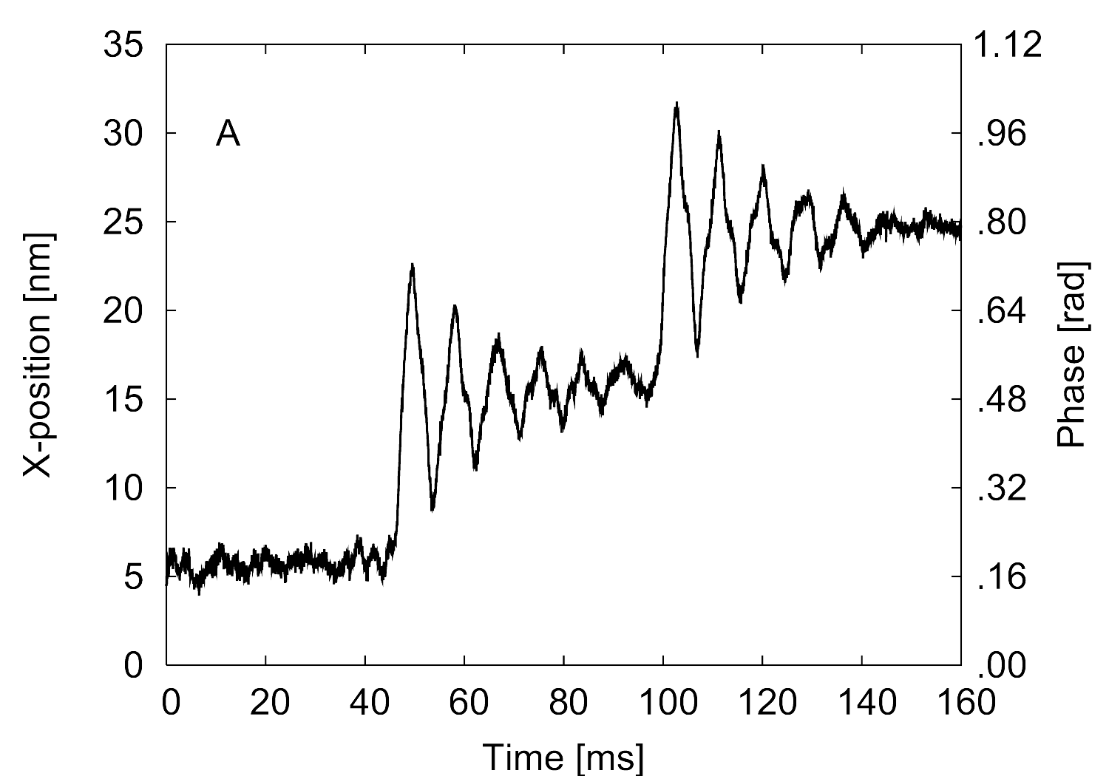 | 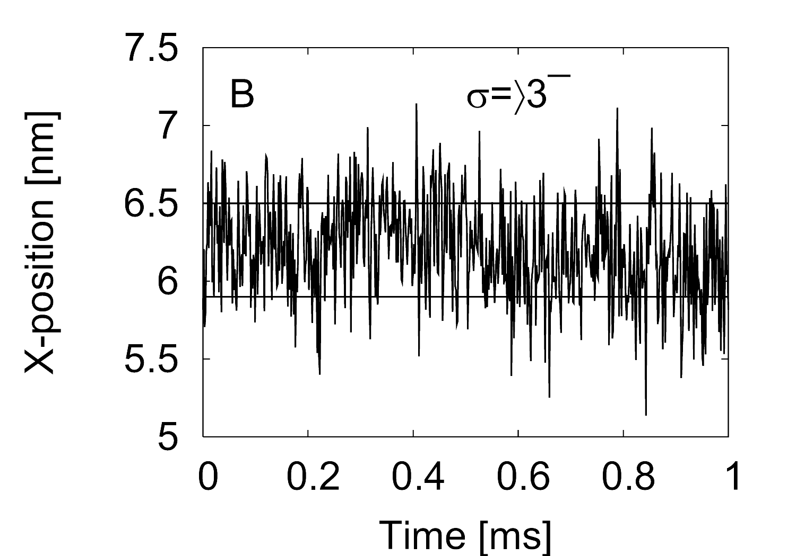
Figure 3 : A) A single colloid (diameter 200 nm) is ¯fixed on the coverglass, while the sample holder
is moved in 10 nm steps by means of a calibrated piezoelectric stage. B) the residual shot noise
limits the resolution to 3 Angstroms RMS.

A new setup for TWT is being built at TU-Delft that will complement the one at the Curie institute. The initial design is based on the setup at the Curie institute. It will have several improvements with the idea of obtaining a better stability, resolution and signal to noise ratio. A future goal would be to expand the capabilities of this system to track not only displacements in 2 directions but in 3 directions with a time resolution above 30 kHz. Vibration isolation is very important, for that we are setting up a new active optical table and, in order to reduce other sources of noise, most of the setup will be in a box under controlled atmosphere and the illuminating laser be coupled to the experiment by the use of optical fibers. Other changes include the use of conjugated metallic bead, with dimensions on the order of 40nm in order to take advantage of their large scattering intensity at small dimensions. With these improvements we hope to obtain sub-nanometer resolution with a large bandwidth.

Structures design

A few preliminary experiments, based on the TWT detection, have been carried out on the kinesin-microtubule complex. The Neurospora kinesin motion has been studied by labeling the motor with a 100nm particle: the kinesin motion has been recorded with microsecond resolution and the characteristic 8 nanometer steps have been observed. These preliminary measurements strongly indicate that the thermal fluctuation of the bead, and the vicinity of the surface, partially hide the short-time details of the steps. In order to overcome this effect, two solutions have been considered:

- a direct manipulation of the kinesin-coated bead by using an optical tweezers setup will allow us to partially stretch the kinesin-bead link and therefore to stiffen the bond and reduce the Brownian motion of the bead. This tool will be implemented first at the Institut Curie.
- an increase of the kinesin-surface distance, by attaching the microtubule ends to two nanopillars instead of fixing them directly to the coverglass (Figure 4b), will decrease the interaction between the bead and the surface

At TU-Delft, and in collaboration with the Institut Curie, several structures for the TWT setup have been designed and tested. The new structures are designed with the idea of letting the object of study move freely in 3 dimensions and not be constrained by a surface in such a way that the beads used for tracking can move around the object under study. With that purpose in mind, the different structures involve the definition of some kind of trench or hole, with dimensions varying from 300 nm to 1.5 μm on the side, onto which the various molecules under study can be suspended. The samples are created using electron beam pattern generator where, with high resolution, several test structures are defined and are such that there are many shape combinations on one chip. Figure 4 (a) and (b) display side views of typical configurations of the samples tested. Two different approaches were used one based on all glass and the other one, metal on glass. Figure 4 (c) displays a test under TWT illumination for a metal on glass sample where scattering from the side of the trenches can be observed in one direction but not on the perpendicular direction.

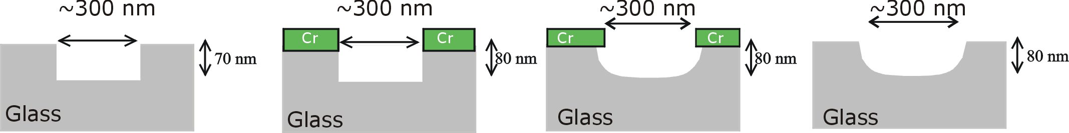(a)
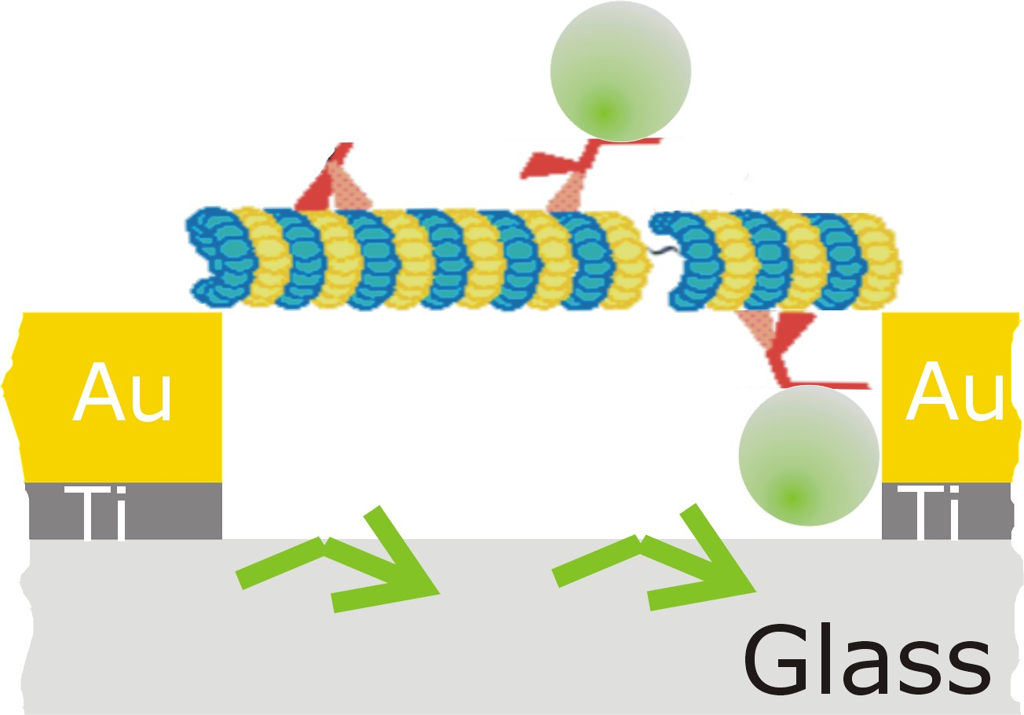 (b) | 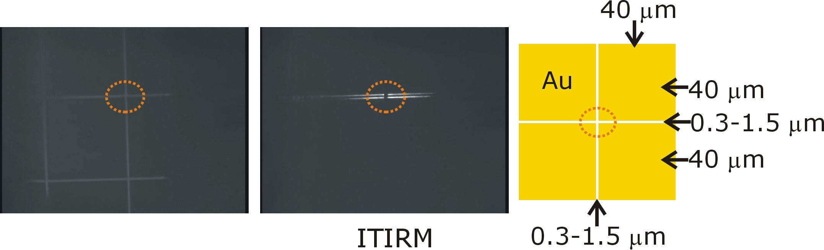(c)
Figure 4

BioMolecular transporter in Nanotechnology

The biological cell utilizes motor proteins for the active transport of material. For example, kinesin motor proteins can bind to a cargo and walk along microtubules, which are long and stiff tubular proteins. In vitro, this system can be reconstituted in a gliding assay (Figure 5). Kinesin proteins are absorbed onto a substrate, propelling the microtubules using the energy of ATP hydrolysis.

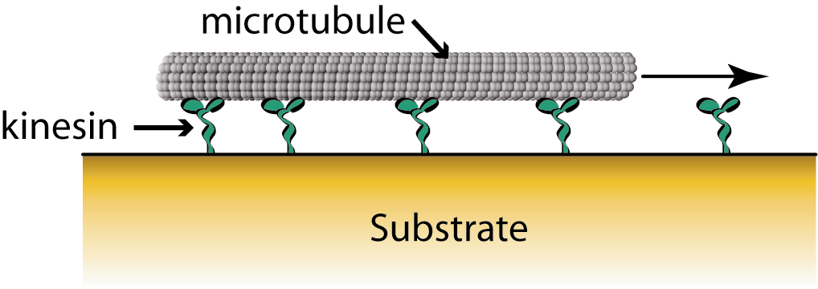  Figure 5:  gliding assay |  | Figure 6 : Fluorescence image showing microtubules moving over the gold, but not over the SiO₂  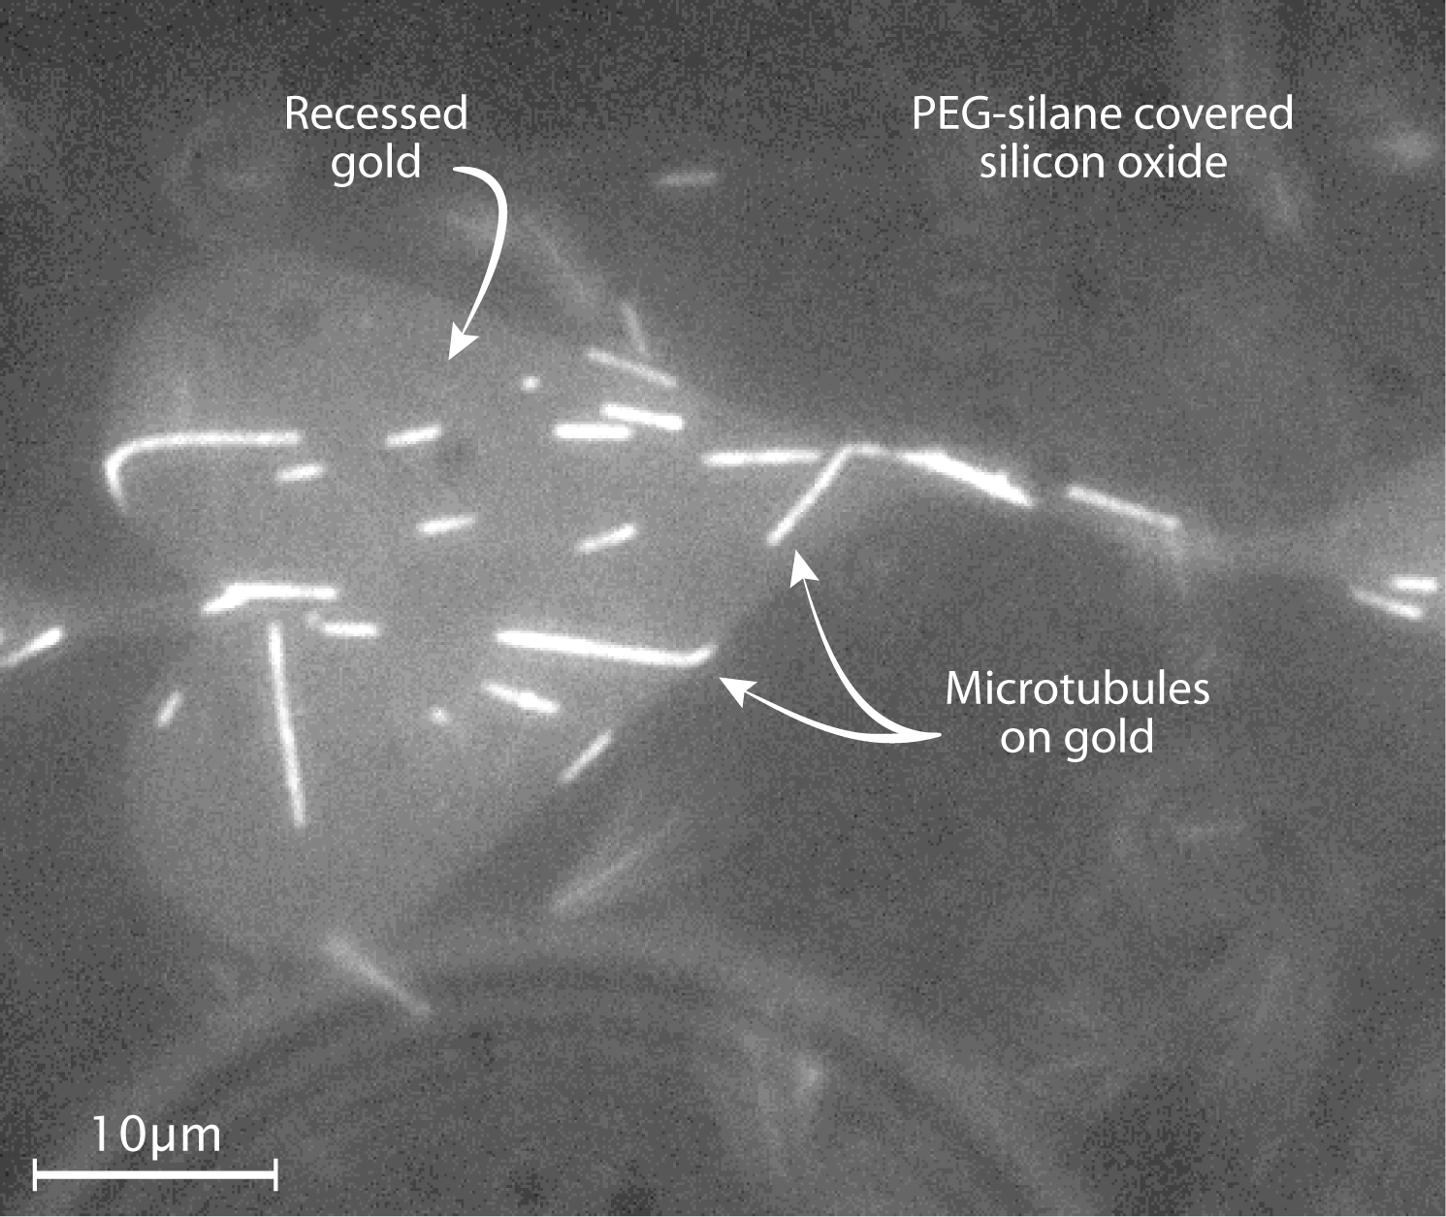
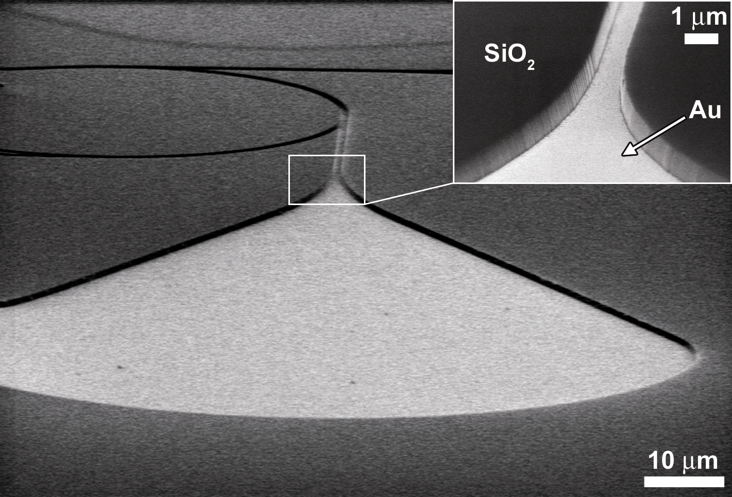
Figure 7: Scanning electron microscope picture of a nanostructure

The use of those biomolecular motors as transporters in nanotechnology has been explored in the Delft group. Nanofabrication techniques and specific chemical absorption have been used to create tracks for microtubule shuttles. Gold-covered trenches in silicon-oxide (SiO2) chips (Figure 7) are created by using a combination of e-beam lithography, reactive-ion etching and e-beam evaporation. The protein absorption on the SiO2 is blocked by grafting a poly-ethylene-glycol (PEG) self-assembled monolayer (SAM) such that kinesin molecules only absorb on the gold covered trench bottoms. Microtubules can be visualized moving only over the gold areas using fluorescence microscopy (Figure 6).
The experiments also demonstrated the localized electrical control of the docking of microtubules onto engineered kinesin-coated structures. After applying a voltage to a gold electrode, we observe an enhanced transport of microtubules from solution towards the surface, and a subsequent increased amount of moving microtubule shuttles (Figure 4). Switching off the voltage leads to a partial detachment of microtubules from the surface. The area coverage of microtubules, during both the docking and undocking events, follows exponential time dependence (Figure 5). We have developed a simple kinetic model, incorporating the equilibrium between free and surface bound microtubules, to explain these data.

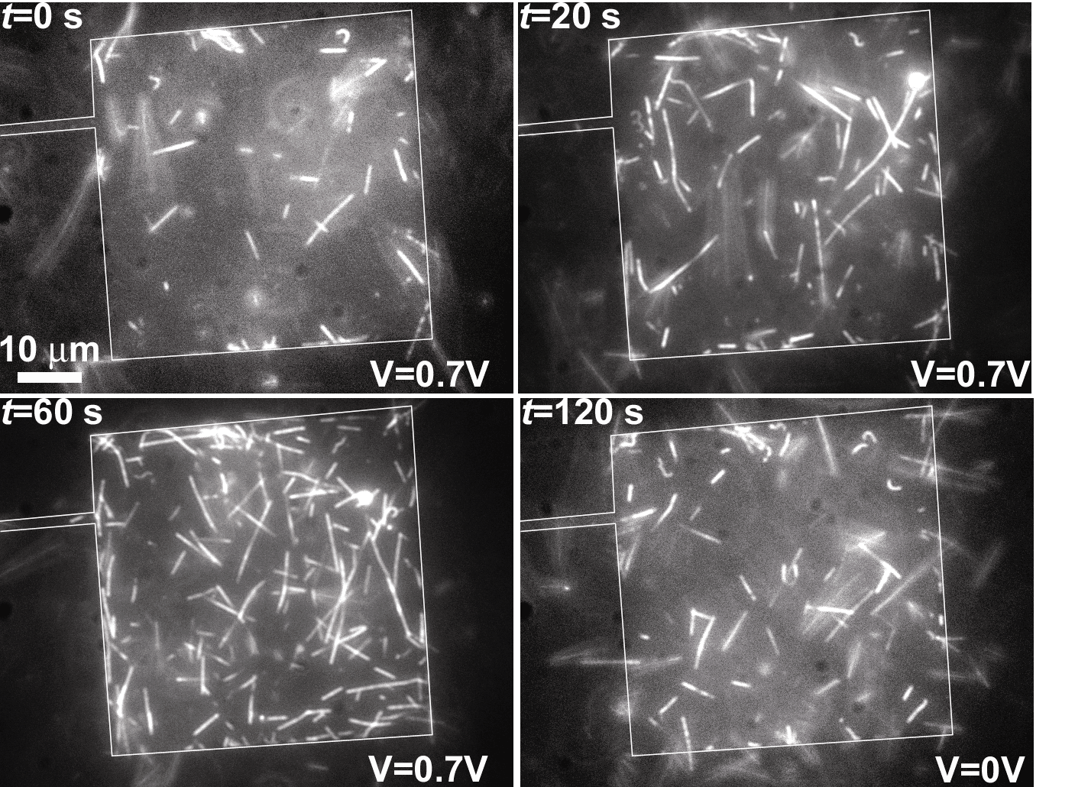 | 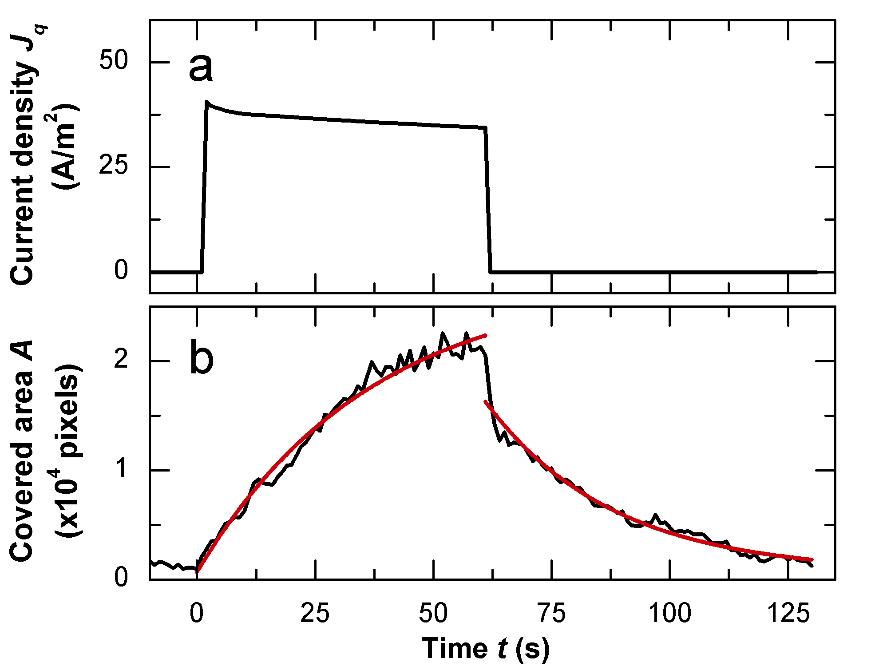
Figure 8 : Time-lapse of fluorescence images showing microtubules docking onto a gold electrode upon application of a voltage. | Figure 9: Timetraces of current density (a) and microtubule density (b) corresponding to the event shown in figure 4.

van den Heuvel, M. G. L.; Butcher, C.; Lemay, S. G.; Diez, S.; Dekker, C. Nano Lett. 2005, 5(2), 235-241.

